CSCIU511 OPERATING SYSTEMS

LABORATORY ASSIGNMENT ONE

DEADLINE: SEPTEMBER 23RD

1. Run the command: mkdir ~/dir1/dir2 How can the error be fixed?
   1. Assuming you want to create 2 directories at the home directory “~/” you would need to place a space after the dir1 and add a “~”. The command should look like mkdir ~/dir1 ~/dir2.
2. The operators <, > and >> important. There's also (unsurprisingly) a << operator. Find out how to use it both and provide 2 examples of each.
   1. “>” appends to the bottom of a file…
      1. the results of a tail command could be appended to the bottom or last line of a file.
      2. Adding the results of a command such as the
   2. “>>” overwrites the contents or replaces the content of the file
   3. “<”
   4. “<<”
3. Work out what each piece of this command does: cut -f1 -d" " ~/.bash_history | sort | uniq -c | sort -nr | head 10. Add an alias to your configuration file so that running ls (with no additional options) gives a colored output.
   1. Cut will allow you to specify a field with the “-f” flag…1 will be the field name you return and ‘-d’ is the delimiter which in our case is a space denoted by the “ “ .
   2. ~/.bash_history tells the filet to go home by the ~/ and the .bash_history is a “dot file to hold the list of all command you have run.
   3. The sort command is literally as it sounds and will sort results based on your input. This is delimted by the character flag ‘-c’.
   4. The sort will sort all of the results based on flags, which in our case the ‘-nr’ which stands for non-recursive.
   5. The head indicates the ‘head’ of the file or line 1….this will read in the and ouput the first 10 lines.
   6. To create an alias… at the bottom of your .bashrc or in mycase .zshrc file you need to add the lines: alias bashhist=’ cut -f1 -d" " ~/.bash_history | sort | uniq -c | sort -nr | head 10’ this will create a shortcut or alias.
4. Create a directory containing several files. Produce a tarball of that directory. Find out how to compress the tarball both at the same time the tarball is created and after an uncompressed tarball has been created
   1. 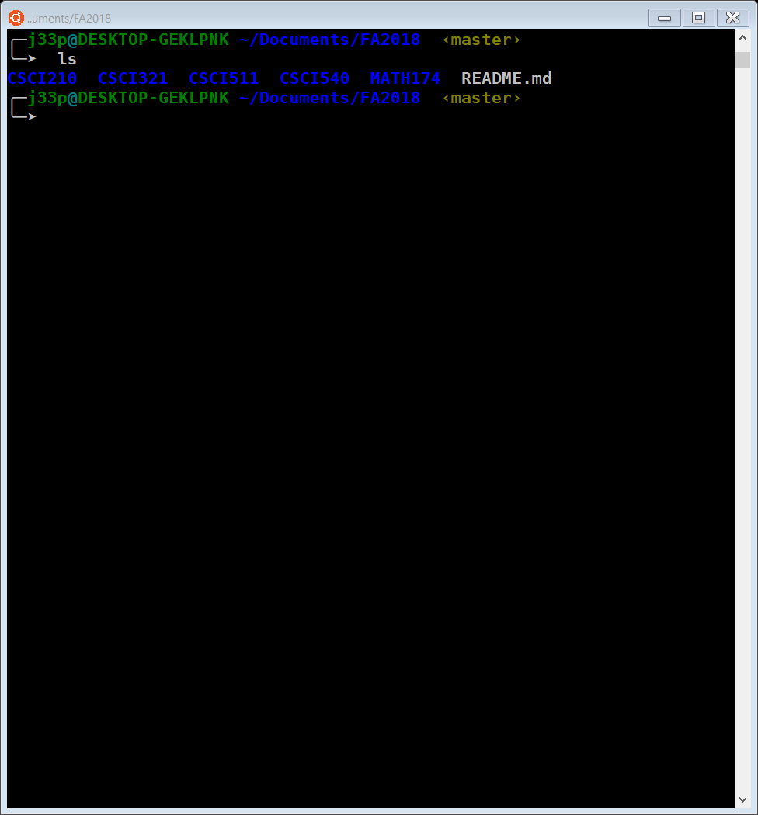

1 Dir with several files in it.

* 1. A screenshot of a computer

     Description generated with high confidence
  2. A picture containing clock, object

     Description generated with very high confidence

Tarball created as school.tar

1. Suppose a short-term scheduling algorithm favors those processes that have used little processor time in the recent past.1) Explain why this algorithm favors I/O-bound processes.2) Explain why this algorithm does not permanently deny processor time to CPU-bound processes
2. In the Exec II batch system, users would submit a large number of jobs in the morning. These jobs took hours to complete and thereby prevented fast response. Suggest a modification of the scheduling policy that would discourage users from doing this.
3. In the Scope system for the CDC 6600 computer, system resources (processor time, storage, etc.) can remain idle while running jobs wait for operators to mount magnetic tapes. Suggest a solution to this problem
4. Consider the following set of processes, their arrival times and expected running times. For each of the following scheduling algorithms, determine the mean process turnaround time and mean waiting time. Ignore process switching overhead.(a) Round Robin (q = 10) (b) First-Come, First-Served (run in alphabetical order) (c) Shortest Job First

|  |  |  |
| --- | --- | --- |
| 1. Process | 1. ERT | 1. Arrival |
| 1. A | 1. 85 | 1. 0 |
| 1. B | 1. 30 | 1. 10 |
| 1. C | 1. 35 | 1. 15 |
| 1. D | 1. 20 | 1. 80 |
| 1. E | 1. 50 | 1. 85 |

1. Consider a swapping system in which memory consists of the following hole sizes in memory order: 10 KB, 4 KB, 20 KB, 18 KB, 7 KB, 9 KB, 12 KB, and 15 KB. Which hole is taken for successive segment requests of
   1. 12 KB
   2. 10 KB
   3. 8 KB

for First Fit? Now repeat the question for Best Fit, Worst Fit, and Next Fit

1. A computer has four page frames. The time of loading, time of last access and the R and M bits for each page are as shown below (the times are in clock ticks):
   1. (a) Which page will NRU replace? (b) Which page will FIFO replace? (c) Which page will LRU replace? (d) Which page will second chance replace?

|  |  |  |  |  |
| --- | --- | --- | --- | --- |
| Page | Loaded | Last ref. | R | M |
| 0 | 126 | 280 | 1 | 0 |
| 1 | 230 | 265 | 0 | 1 |
| 2 | 140 | 270 | 0 | 0 |
| 3 | 110 | 285 | 1 | 1 |

For each of these algorithms, which page will be replaced?